Software Requirements Specification

for

LOCGALLERIA

Version 1.0 approved

Prepared by

Muhammad Zaman (51884)

Syed Shabbir Ahmed (49868)

Waleed Shahid (49728)

Supervisor: Ayesha Iftikhar

Date: 30 Dec 2022

Table of Contents

Table of Contents ii

Revision History ii

1. Introduction 1

1.1 Purpose 1

1.2 Intended Audience and Reading Suggestions 1

1.3 Product Scope 1

1.4 References 1

2. Overall Description 2

2.1 Product Perspective 2

2.2 Product Functions 2

2.3 User Classes and Characteristics 2

2.4 Operating Environment 2

2.5 Design and Implementation Constraints 2

2.6 User Documentation 2

2.7 Assumptions and Dependencies 3

3. External Interface Requirements 3

3.1 User Interfaces 3

3.2 Hardware Interfaces 3

3.3 Software Interfaces 3

3.4 Communications Interfaces 3

4. System Features 4

4.1 System Feature 1 4

4.2 System Feature 2 (and so on) 4

5. Other Nonfunctional Requirements 4

5.1 Performance Requirements 4

5.2 Safety Requirements 5

5.3 Security Requirements 5

5.4 Software Quality Attributes 5

5.5 Business Rules 5

6. Other Requirements 5

Appendix A: Glossary 5

Appendix B: Analysis Models 5

Appendix C: To Be Determined List 6

Revision History

|  |  |  |  |
| --- | --- | --- | --- |
| **Name** | **Date** | **Reason For Changes** | **Version** |
|  |  |  |  |
|  |  |  |  |

# Introduction

Each province in Pakistan holds different cultural significance in their handicrafts but among all, Balochi and Pathani embroidery deserves special mention. Balochistan is home to many handicrafts in traditional clothing, there are numerous local shops and vendors including women that offer exquisite designs of traditional clothing and accessories that most people are obsessed with buying. Many women in this region are dependent on these handicrafts for livelihood and economic support, they use embroidery as a cradle for their economic empowerment. Local vendors and shops are only restricted to limited number of customers, as a consequence huge potential for income particularly for local vendors has remained unexplored and city like Quetta with its traffic problem, it is difficult for a person to visit the local market easily and with these busy schedules and household chores in line especially for women, it is also time taking to explore local market.

For this purpose, an online platform that integrates all the local shops and vendors in order to boost up the their sale by connecting them with broader local audience and not only that also connect local vendors with customers from other cities which would likely patronize their business in the near future. Our platform can provide an enabling environment for women to cash their talent and establish their own business and through this platform women can get a better prize for their products.

## Purpose

Living in a city like Quetta with its traffic problem and busy life, it is difficult for a person to visit different clothing shops, compare their prices and then visit different tailor shops and test their stitching quality. For this purpose, an online system that integrates all these shops into one place, provide a home delivery service. Moreover, disabled and aged people are unable to go through this drill.

## Intended Audience and Reading Suggestions

This document is intended for panel members of BS IT project committee members, Supervisor, and Developers.

## Product Scope

1. User will be able to create account or login as a guest.
2. User can create user account or business account to register as customer or supplier.
3. User can sell their home made handicraft through this platform.
4. User can choose product from multiple shops or embroidery suppliers.
5. User can upload product to their shop dashboard easily.
6. Customers can choose products as per their preferences.
7. All the clothing, local cultural, embroideries, and accessories shops will be integrated together at one platform.

## References

[React Native · Learn once, write anywhere](https://reactnative.dev/)

[GitHub: Let’s build from here · GitHub](https://github.com/)

# Overall Description

## Product Perspective

Our perspective is to integrate local shops of local market and to provide a platform to sellers and customers to sell/buy products online. It is difficult for a person to visit different clothing shops, compare their prices and then visit different tailor shops and test their stitching quality. For this purpose, an online system that integrates all these shops into one place, provide a home delivery service. Moreover, disabled and aged people are unable to go through this drill. Users can use our sites as a customer and vender if want to sell homemade handicrafts to gain economical support.

## Product Functions

**Software Requirements**

* VS Code

**Hardware Requirements**

* Android phone
* IPhone
* Laptop/PC

**Functional Requirements**

1. **Login**

* User can login as a guest or by registered account
* User can create customer or Business account

1. **Add Items**

* User can add products to shop’s dashboard
* User can add product to cart
* User can edit products priority and label

1. **Delete Item**

* User can delete sold items from shop’s dashboard
* User can delete product from cart list

**Non Functional Requirements**

* **Usability Requirement**

The site shall allow the users to access the system from the phone using specified site link. Since all users are familiar with the general usage of website, no special training is required. The system is user friendly which makes the system easy.

* **Availability Requirement**

The system is available 100% for the user and is used 24 hrs a day and 365 days a year within the premises of local area. The system shall be operational 24 hours a day and 7 days a week.

* **Accuracy**

The system should accurately provide real time information taking into consideration various concurrency issues. The system shall provide 100% access reliability.

* **Reliability**

The system has to be 100% reliable due to the importance of data and the damages that can be caused by incorrect or incomplete data.

## User Classes and Characteristics

We have two levels of users

1. **Vendor Module**

* Can add products to the dashboard
* User can manage ordered products
* User can update products list by removing sold products

1. **Customer Module**

* User can view products of multiple shops
* User can add products to cart and can remove it from cart
* User can place order
* User can choose payment method

## Operating Environment

This is an independent single page application that will operate in android, IPhone, and laptop/PC. This will operate in the significant area for local market to support users and vendors.

## Design and Implementation Constraints

**Use case diagram:**

## 

User side user case.

## 

Seller/vendor side use case

**Data Flow Diagram:**

## 

**System flow diagram:**

## 

**Component diagram:**

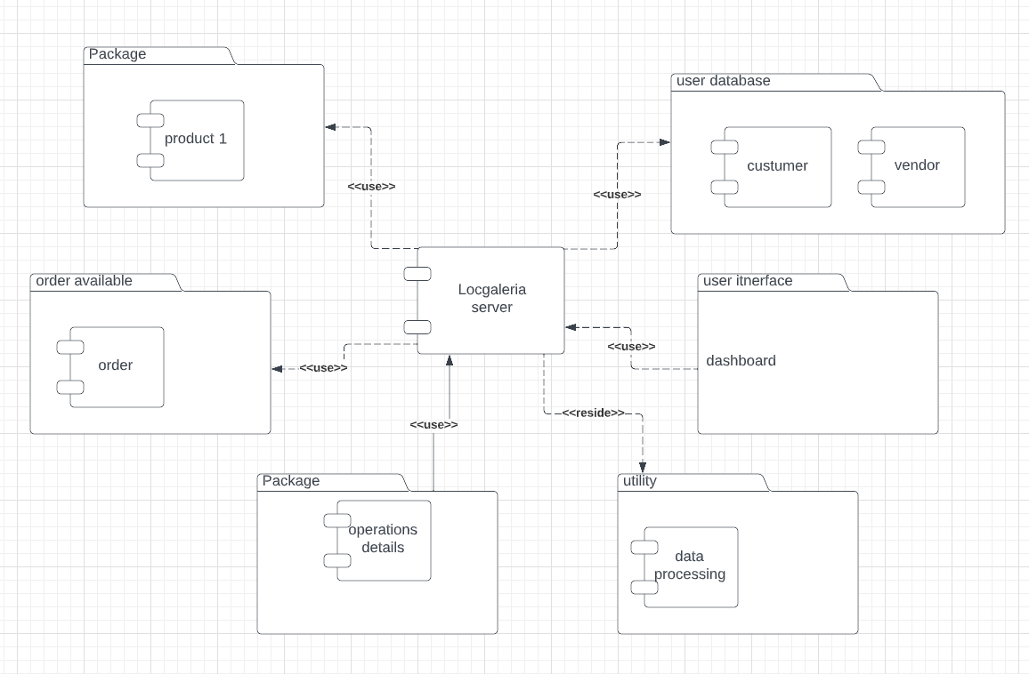

**Activity diagram:**

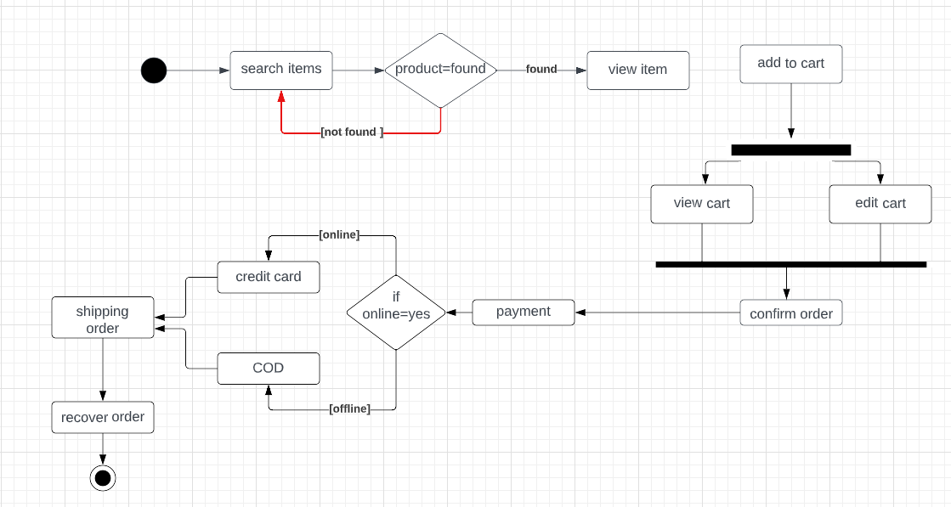

**Sequential diagram:**

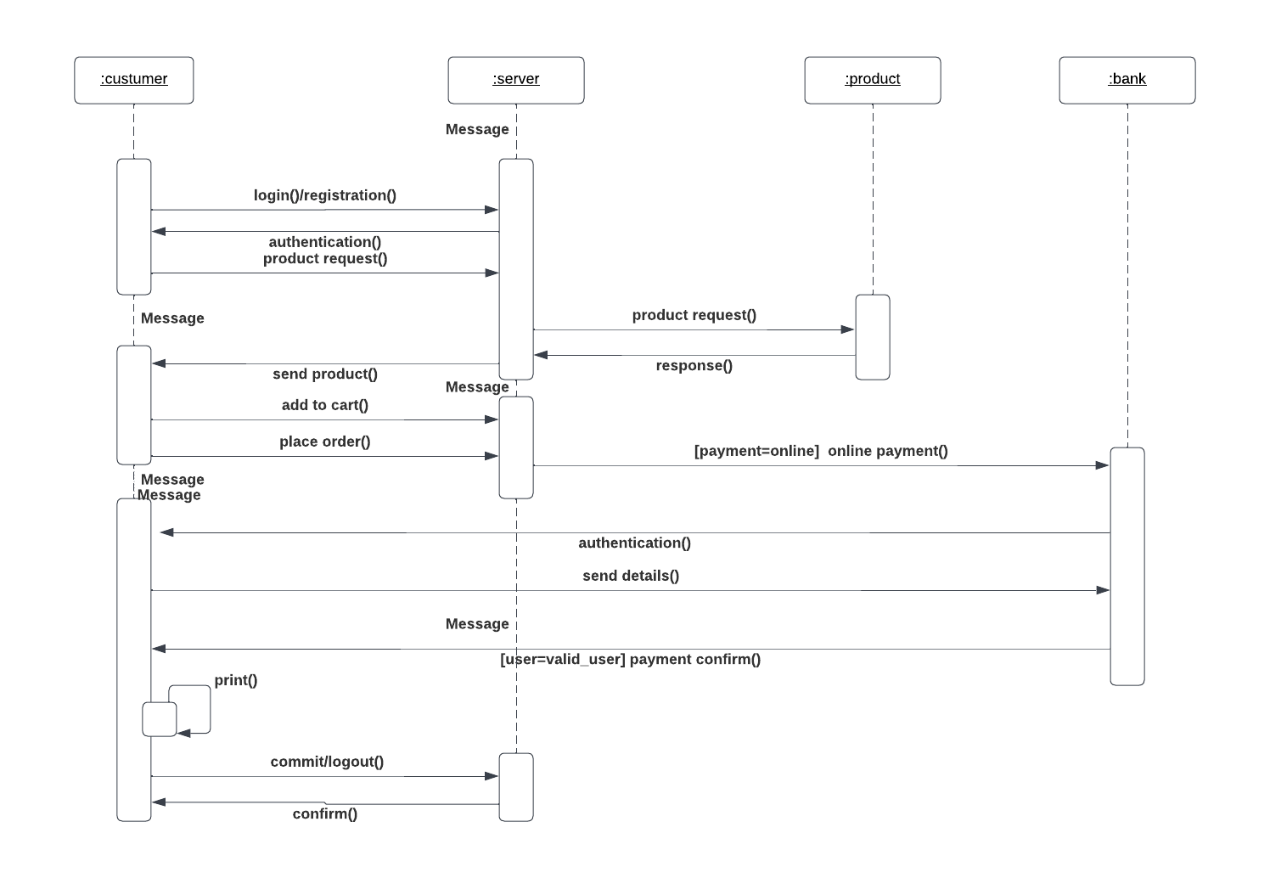

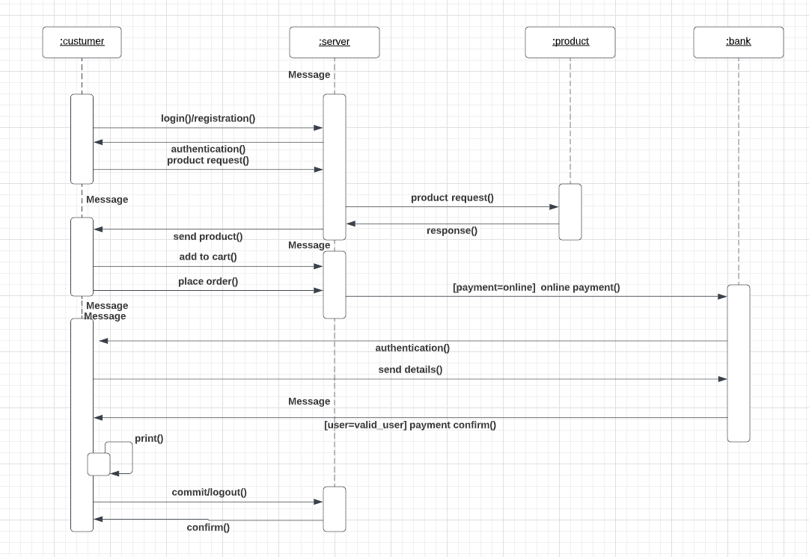

**Class diagram :**

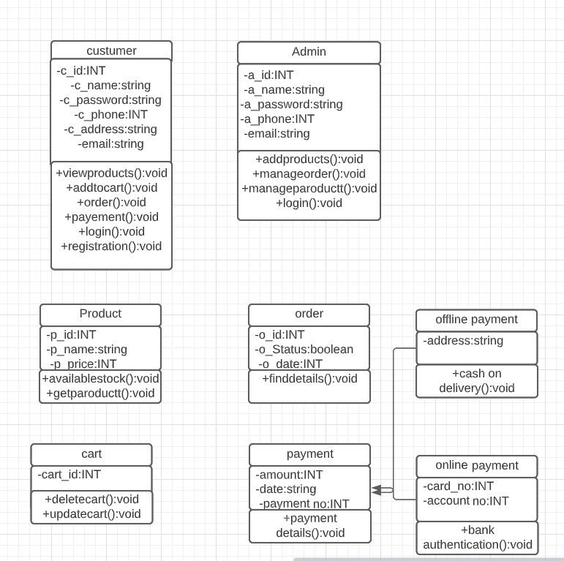

seller

-s_id:INT

-s_password:INT

-s_phone:INT

-s_address:String

-s_email:String

+addproducts():void

+manageshopproducts():void

+manageshoporder():void

+login():void

## User Documentation

A documented user manual will be provided along with it in initial release of the software and tips to run the application will be installed with it once it’s launched for our customers.

## Assumptions and Dependencies

The product need the following third party applications for development:

# Visual studio code

1. My SQL

# External Interface Requirements

## User Interfaces

1. Main page

# 

1. Login page

# 

## Hardware Interfaces

The minimum hardware requirements of Locgaleria webapp are a single core android phone, desktop or laptop with 1Ghz CPU or above with memory 1gb or above.

Or an Apple iPhone 4 or newer.

## Software Interfaces

The Locgaleria webapp will require any windows for desktop i.e. Seven or Latest version of windows and android phones and iOS 4.0 or newer version for iPhones.

## Communications Interfaces

Locgaleria webapp will require an internet connection for communication between customers and vendors and all the customers and vendors data will be stored in database.

# System Features

## Log In

**4.1.1 Description and Priority**

User can visit website as a guest or Users will be asked to enter their valid username/email and password to be authenticated. After authentication the user will see the landing page.

**Priority Level:** High

**4.1.2 Stimulus/Response Sequences**

1. The user clicks on the signup option.
2. The user will be asked if he’ll be logging in as a customer or a vendor

3. The user enters his/her Username/email and password and clicks on the “login” button.

4. The system authenticates the user

5. The system displays the landing page upon successful authentication.

**4.1.3 Functional Requirements**

REQ_01: User shall only be able to log in with valid login credentials.

REQ_02: The website shall authenticate login credentials (username/password and password).

## Browse products

**4.2.1 Description and Priority**

This requirement is primarily for the Website and will allow the user to select or browse products to buy.

**Priority Level:** High

**4.2.2 Stimulus/Response Sequences**

1. The user will click on the browse products to explore products provided by vendors and then place their order.

**4.2.3 Functional Requirements**

REQ_01: user shall be only able to place his order if he has logged in via his account.

## Add items

**4.2.1 Description and Priority**

This requirement is primarily for the vendors and will allow the user to add new products in his virtual shops dashboard

**Priority Level:** High

**4.2.2 Stimulus/Response Sequences**

1. The user will click on the Add item to add new product.
2. After adding the item, it will show the list of items on the shop’s dashboard including new items.

**4.2.3 Functional Requirements**

REQ_01: user shall be only be able to add new item if it isn’t already in his dashboard.

## Delete items

**4.3.1 Description and Priority**

This requirement is primarily for the vendors that will allow the user to delete an existing item from his dashboard

**Priority Level:** High

**4.3.2 Stimulus/Response Sequences**

1. The user will click on delete item
2. It will be connected to the items database.
3. User shall be able to delete the existing item.

# Other Nonfunctional Requirements

## Performance Requirements

An application or a website is known by its best performance and accuracy, that is what makes it a useful application. In our project the response time of the website will be on time and accurate. The main goal is to provide better and accurate result of the communication between database and website.

## Safety Requirements

## Security Requirements

The user has to login with its username/email id and password that he has used for the registration that will be stored in our database, any other than that the user cannot log in to their accounts or use them.

A single database will be used to store and retrieve which is the more secure and reliable way to interact with.

## Software Quality Attributes

* The software should be reliable to use.
* The communication between website and database should be efficient.
* The webapp should be secure.
* The webApp should be saleable.
* Others: Usability, availability, Performance.

## Business Rules

1. The application will interact with CMS system of the organization.
2. You can mark attendance of the students manually.
3. You can mark attendance of the students by scanning the CMS IDs through camera of your mobile devices.
4. Multiple account will be supported of chairpersons and lectures.
5. Application will send and receive data from the main server of the organization.
6. Providing more accurate results of the OCR scans.
7. OCR will be able to extract the handwritten numerical digits from the sheet.
8. Marking leave from the chairpersons account and notifying the course instructor.